Unit 4 Lesson 9 The Bouncing Ball Activity
Your teacher will show you one or more videos of a tennis ball being dropped or a set of still images.
The height of the ball is a function of time. Suppose the height is h feet, t seconds after the ball is dropped.
Use a blank coordinate plane to sketch a graph of the height of the tennis ball as a function of time. Before sketching your graph, it may help to complete a table of values using information gathered from the videos or images.
Time  (seconds) | 0 | 0.28 | 0.54 | 0.74 | 1.03 | 1.48 | 1.88 | 2.25
Height
(feet)
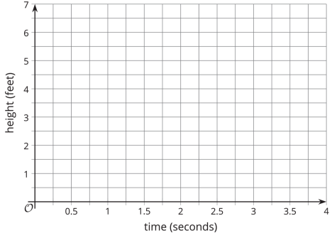
- Identify horizontal intercepts (x-intercepts) of the graph. Explain what the coordinates tell us about the tennis ball.

- Identify vertical intercepts (y-intercepts) of the graph. Explain what the coordinates tell us about the tennis ball.

- Find the maximum values of the function. Explain what they tell us about the tennis ball.

- Find the minimum values of the function. Explain what they tell us about the tennis ball.

Are you ready for more?
If you only see the still images of the ball and not the video of the ball bouncing, can you accurately graph the height of the ball as a function of time? Explain your reasoning.

